Computer Networking

Data link Layer Assignment

**Name: 何雨璇**

**Student number: 2022280445**

**The Question：**

1. What are the hexadecimal values for the source and destination addresses in the Ethernet frame containing the ARP request message?

The first ARP frame:

Source: AmbitMicrosy_a9:3d:68 --00:d0:59:a9:3d:68

Destination: Broadcast --ff:ff:ff:ff:ff:ff

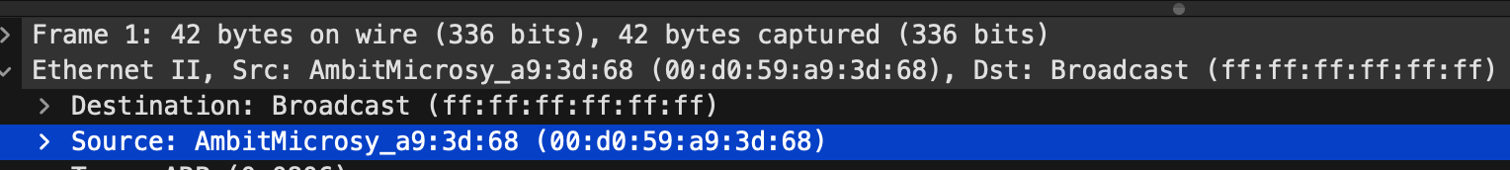

11.Give the hexadecimal value for the two-byte Ethernet Frame type field. What upper layer protocol does this correspond to?

the hexadecimal value for the two-byte Ethernet Frame type field: 0x0806

upper layer protocol: ARP

截屏2024-01-03 21.47.18

13.

1. How many bytes from the very beginning of the Ethernet frame does the ARP opcode field begin?

16 + 5 = 21 Byte

1. What is the value of the opcode field within the ARP-payload part of the Ethernet frame in which an ARP response is made?

Opcode: reply --2

截屏2024-01-03 21.55.38

1. Where in the ARP message does the “answer” to the earlier ARP request appear – the IP address of the machine having the Ethernet address whose corresponding IP address is being queried?

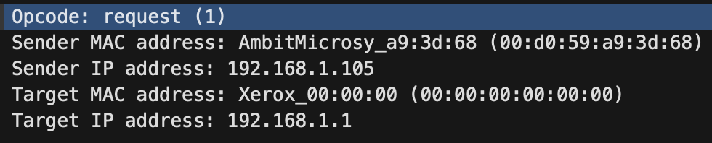

14.What are the hexadecimal values for the source and destination addresses in the Ethernet frame containing the ARP reply message?

The reply ARP frame:

Source: LinksysGroup_da:af:73 --00:06:25:da:af:73

Destination: AmbitMicrosy_a9:3d:68 --00:d0:59:a9:3d:68

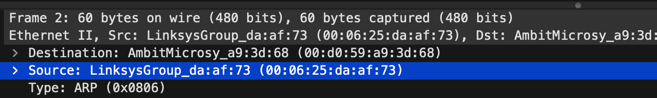

**The ARP frames from myself:**



we can analysis the information:

Destination: Broadcast --ff:ff:ff:ff:ff:ff

Source: 46:51:ad:a9:34:6e

Type: ARP (0x0806)

Address Resolution Protocol --request

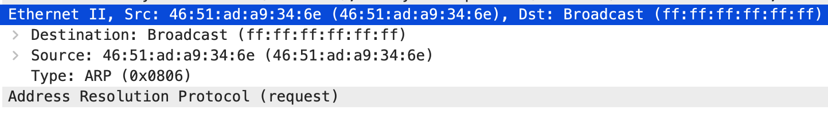

I only captured the request packet .So i will campare the frame with the first request frame.



Frame number and time: the frame number of my ARP data frame is 968, and the timestamp is 18.022364. the frame number of the gived ARP data frame is 1, and the timestamp is 0.000000, which means that they occurred at different points in time.

Source Address: The source address of my ARP data frame is 82:58:60:c6:e8:3f, while the source address of the gived ARP data frame is AmbitMicrosy_a9:3d:68. These two addresses are different, which indicates that two different devices sent the ARP request.

Destination Address: The destination addresses of both ARP data frames are broadcast addresses, i.e., they need to be broadcast to all devices on the network.

Frame Length: The frame length of both ARP data frames is 42 bytes.

ARP request content: The content of the two ARP requests is for different IP addresses. mine is for 172.26.144.1 and the gived one is for 192.168.1.1.